
Company
Logotype

Cone Beam Computed Tomography- Report



Porur Dental X-rays & CBCT

Patient Name : Mrs. Dimble Singh | Date of Report : 28.12.2024
Age/ Gender : 51 years/ Female | Region of Interest : CBCT Sectional Maxilla
Referring doctor: Dr. Selva Ganesh | Indication : Assessment of 17
Clinical Notes: Nil
PATIENT INFORMATION

CBCT- Sectional Maxilla provided
CBCT – IMAGE DETAILS

RADIOGRAPHIC INTERPRETATION

- In relation to 17, presence of hyperdense restorative material involving the crown and extending into the disto- buccal and palatal root canal upto the apical third is evident. The course of the mesio-buccal root canal is evident.
- In relation to 16, presence of hyperdense restorative material involving the crown and extending partially into the buccal and palatal root canal upto the apical third is evident.
- In the distoproximal aspect of 16, partial loss of crown evident. Resorptive changes evident in the apical aspect of its mesio buccal root along with a diffuse periapical hypodensity measuring 9.3 x 9.87 x 10.33 mm. The hypodense region appears to cause thinning of the buccal and palatal cortical plate and lies close to the floor of maxillary sinus.

Implant assessment in relation to 16
 | 16 region
Sub-Crestal (in mm) | -
Mid- Crestal (in mm) | 2.59
Distance between the alveolar ridge and floor of the maxillary sinus  (in mm) | 0.77

RADIOGRAPHIC IMPRESSION

- Incompletely root canal treated tooth: 16 with periapical pathology.
- Incompletely root canal treated tooth: 17

Kindly correlate with clinical findings


IMAGES FOR REFERENCE

RECONSTRUCTED PANORAMIC VIEW

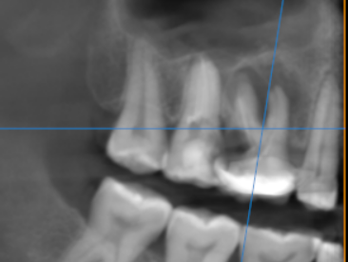

3-DIMENSIONAL VIEW
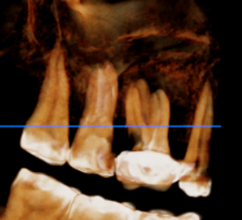

CROSS SECTIONAL VIEW- 17 region

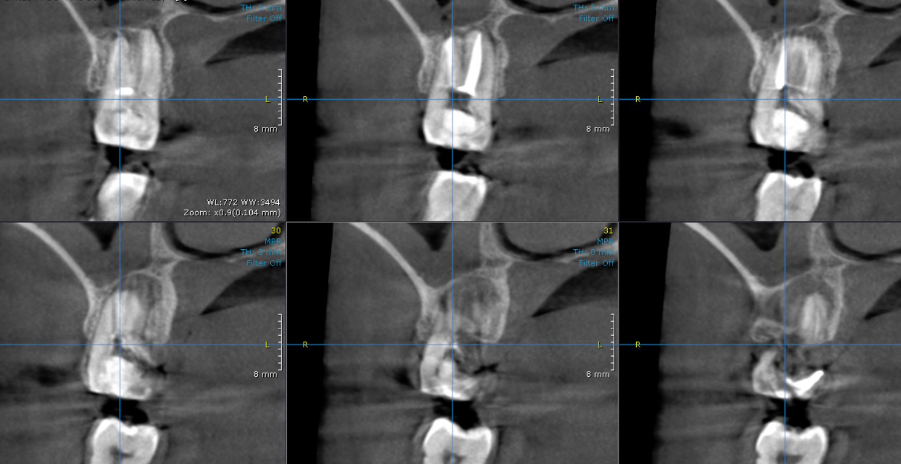
Mesio buccal canal

CROSS SECTIONAL VIEW- 16 region

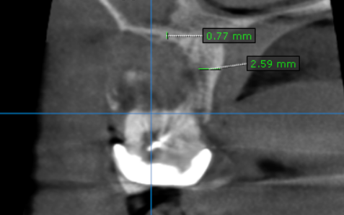

**** End of report ****

